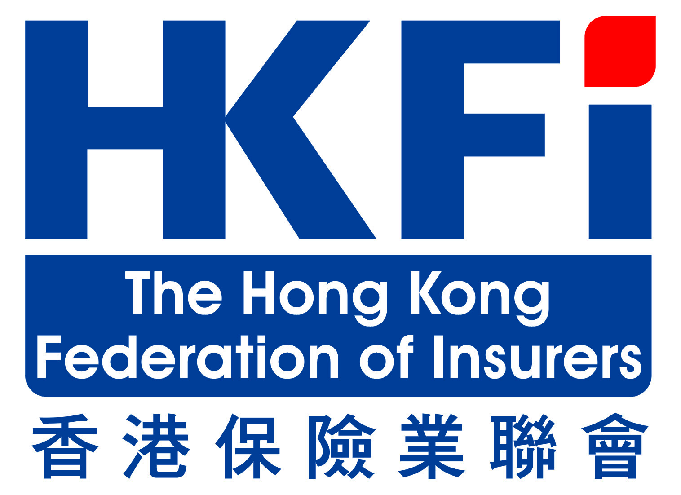 | 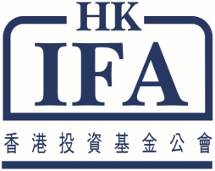 | 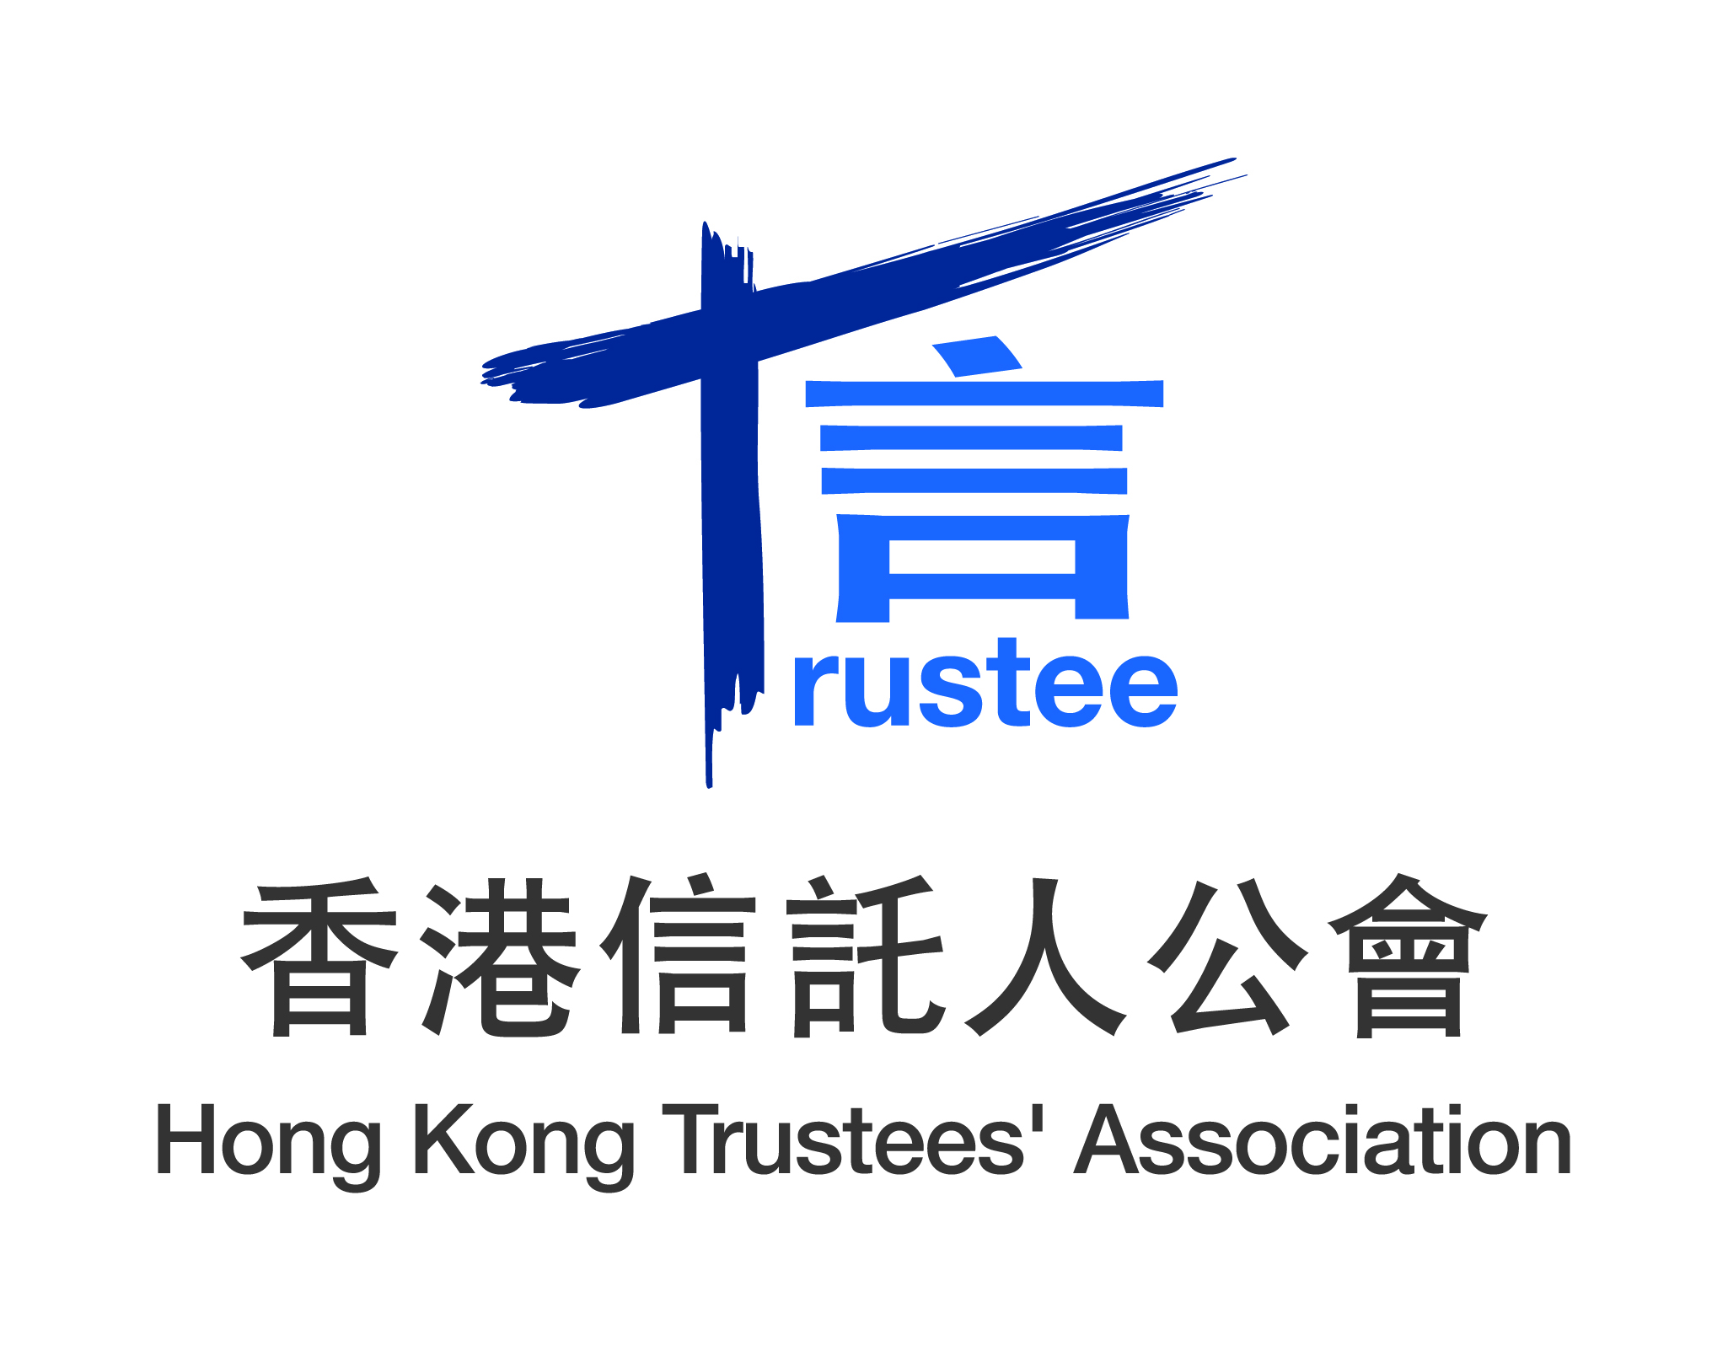

IMMEDIATE RELEASE

Hong Kong MPF achieves intended objectives but more communication to public of its benefits is desired

Hong Kong, 24 May 2012 – According to a study conducted by Ernst & Young, the Hong Kong Mandatory Provident Fund system achieved its intended objectives as an occupational retirement savings vehicle for Hong Kong’s working population.

The study was commissioned by a Joint Industry Group (“JIG”) comprising Hong Kong Federation of Insurers, Hong Kong Investment Funds Association and Hong Kong Trustees’ Association. The aim of the study was to review where MPF stands relative to defined contribution pension systems in other jurisdictions in terms of fund options, fund performance and fees. It also provides an opportunity to see how the MPF system may be improved based on what we learn from more mature systems globally.

The Choice of Reference Pension Systems

The study compared Hong Kong’s MPF to its counterparts in Australia, Chile, Singapore and the United Kingdom. The selection of these Reference Systems was based on the nature of the pension system, industry operating model, size of assets under management, and system maturity. While Singapore has some significant design differences to the MPF system, it is one of the leading Asian pension systems and has been included to provide broader comparability in Asia.

Study findings (1): The MPF system has worked well over the past decade

Over the last 11 years, the MPF regime has grown from nothing to a system that has over 2.5 million members, assets of over HKD365 billion, and one that has achieved full compliance with 99% of employees participating (source: MPFA), thereby ensuring that the working population of Hong Kong have some retirement savings.

Global experience suggests that pension systems take 40 years or so to mature. Hong Kong has progressed very well through the first decade of development supported by a robust infrastructure. Even at this relatively early stage of development, the MPF system offers participating members considerable choice in terms of the number and type of funds that they can invest in, and considerable flexibility to change their investment choices.

Recent developments including fee cuts by most providers, an increase in the maximum level of relevant income (“Max RI”) for mandatory contributions and the upcoming rollout of Employee Choice Arrangement show that the MPF is maturing and entering a new phase of development.

Study findings (2): MPF performed well compared to Reference Systems

Principally because of the investment choices made by MPF members combined with the impact of the Global Financial Crisis, investment performance compared well to the reference jurisdictions over one-year and five-year periods but underperformed over a three-year period.

The majority of members have a bias in asset allocation towards equities, particularly Hong Kong equities. This has helped them to ride through two market crashes. However, it also leads to short term volatility. There are also a large number of participants that have considerable holdings in low risk, low return investments. Over 24% of assets were in bond funds, money market funds and guaranteed funds (Source: MPFA statistics, Dec 2011).

We would like to see participants move to a more balanced approach with a combination of equities and bonds, and more global diversity in terms of these holdings.

Study findings (3): Compared to the Reference Systems fees show grounds for optimism

Fund management fees have benefited from the fact that Hong Kong is a global asset management centre providing a competitive framework and scale, and thus compare favourably with those charged in the Reference Systems.

Total fees including administration and trustee fees are also in line with other jurisdictions at a similar stage of development.

Fees in Hong Kong are heavily influenced by the relatively young age of the MPF system so that total funds invested are smaller than elsewhere (for example, Australia is 20 times the size of Hong Kong in terms of assets) and as importantly due to the Max RI for mandatory contributions and average account balances which are low relative to the Reference Systems. Thus fixed transaction costs can be a significant percentage of a smaller account balance.

Fees are expected to continue to come down as the system matures and delivers greater economies of scale through increasing the Max RI for mandatory contributions and encouragement for higher voluntary contributions.

The industry is keen to work with the MPFA to analyze costs so as to get a better understanding of the challenges and identify areas for further improvement.

Study findings (4): Opportunities for refinement

With a change of Chief Executive and a greater awareness of the issues that will emerge from an ageing population, we see this as an opportune time to map out a path forward.

Retirement systems generally consider three main pillars - Social Security, Occupational Pensions (such as MPF) and Voluntary Savings. The aim is to ensure that total savings are adequate to meet living costs and medical costs in retirement.

A review of the MPF system to set the strategic vision, objectives and investment beliefs will provide clarity for all stakeholders.

Participants choose how their money is invested and this is a valuable benefit of the system. However, many participants do not have the time or expertise to make informed choices. A review of the Reference Systems suggests a process where these participants are encouraged to go into a Default Fund. A framework for Default Funds should be developed that clearly defines accountability and recommends a process for selection.

Study findings (5): Lack of incentive for investment advice impacts members’ retirement benefits

In most developed countries it has long been recognized that individuals need advice so as to better plan for retirement. This planning is usually provided by trained professionals who help set goals for the individual and then look at recommending a plan that includes social security (if any), mandatory and voluntary contributions to occupational pension schemes and voluntary savings invested in other ways.

We recommend that policymakers review the structure of financial advice and remuneration and relax relevant privacy provision under regulation.

Recommendations

Based on the findings and observations set out by Ernst and Young in their report, the Joint Industry Group is recommending the following to deliver improvements to the MPF system and to help the working population of Hong Kong to better achieve their retirement goals.

Communicate the MPF journey and benefits to members | The MPF system has performed comparatively well which is not reflected in recent public perception. We will enhance our communication to members and stakeholders of the journey and objectives of MPF as a long term retirement savings system, and the comparative advantages of the MPF system.
Pursue scale and efficiency to reduce costs and fees as a percentage of assets | The MPF system is small in comparison to the Reference Systems in terms of assets under management and average balances, and this leads to fixed costs being a high percentage of assets. This limits opportunities to benefit from economies of scale. We recommend considering ways to increase mandatory and voluntary contributions, in particular by further increasing the current Max RI for mandatory contributions.
Improving MPF system clarity and vision | Policymakers should provide further clarity and vision including guidance around investment beliefs. Further clarity around fiduciary duties of each stakeholder, and principles on what constitutes the best interests of MPF members are vital components.
Improving personal financial advice and decision support | MPF participants must currently make an informed investment choice with limited decision support and without any regard to their financial literacy. We recommend reviewing the need for an affordable, mass market personal financial advisory framework and solution that can be used by participants with a view to maximizing their long term retirement savings.
Implement operational refinements of some regulatory features | We recommend implementing some operational refinements of some regulatory aspects that have emerged over the past 11 years to streamline the system.

Closing Note

The MPF System was a significant initiative when it was introduced by the Government 11 years ago. Without it Hong Kong would be ill prepared to consider the issues that will arise from a rapidly ageing population.

The Joint Industry Group hopes that this study will lead to debate as to how to take the current MPF system and make it even better so that it can act as a main pillar for ensuring that the people of Hong Kong can enjoy a well earned retirement when they decide to leave the workplace.

- END -

Issued by the Joint Industry Group (HKFI, HKIFA and HKTA)

Media Contact
Chung & Tang Communications Consultants
- Ms Angel Chung
Tel: (852) 2520-2679 or (852) 9098-9878 / Email: angel@cnt.com.hk

About MEMBER ASSOCIATIONS OF THE JOINT INDUSTRY GROUp

The Hong Kong Federation of Insurers (HKFI)

The Hong Kong Federation of Insurers, a self-regulatory body of insurers, was established on 8 August 1988 to advance and promote the development of the insurance business in Hong Kong. Following its conversion to a limited company on 29 December 1994, the HKFI became a consolidated and streamlined organization that enjoys full recognition by the Government of the Hong Kong Special Administrative Region as the representative body of an increasingly important industry. The insurance industry is one of the few industries in Hong Kong that enjoys a high degree of self-regulation complemented by the Government's prudent regulatory framework. While maintaining a frequent dialogue with the Commissioner of Insurance on legislative issues affecting the industry, the HKFI actively promotes and perfects its self-regulatory regime with an aim of improving the professionalism of and strengthening public confidence in the insurance industry. (www.hkfi.org.hk)

Hong Kong Investment Funds Association (HKIFA)

The Hong Kong Investment Funds Association is the professional body that represents the asset management industry in Hong Kong. Established in 1986, the HKIFA has two major roles: consultation and investor education. On consultation, it acts as the representative and consulting body for the fund management industry in all dealings concerning the regulation of unit trusts, mutual funds, retirement funds and other funds of a similar nature. Another very important task is to educate the public about the role of investment funds in retirement planning and other aspects of personal financial planning. HKIFA has 50 fund management companies as full/overseas members, managing about 1,270 HKSFC-authorized funds. Assets under management amounted to about US$1,000 billion as at the end of March 2012. In addition, it has 69 affiliate and associate members. (www.hkifa.org.hk)

Hong Kong Trustees’ Association (HKTA)

The Hong Kong Trustees’ Association was established in 1991 to represent the trust and fiduciary services industry in Hong Kong. As a professional body, the HKTA works closely with various stakeholders of the pension and regulated funds industries to advance development of these industries overall and to promote high standards of professionalism and corporate governance through, among others, education and formulation of best practices for industry practitioners. The Association representing its stakeholders is an authoritative voice in providing advice and responding to consultations by the government, regulators and relevant bodies on legislations/regulations (such as the trust law reform and pension portability) as well as in ensuring that Hong Kong maintains its long-standing position as a reputable international trust, fund and fiduciary services centre. (www.hktrustees.com)

