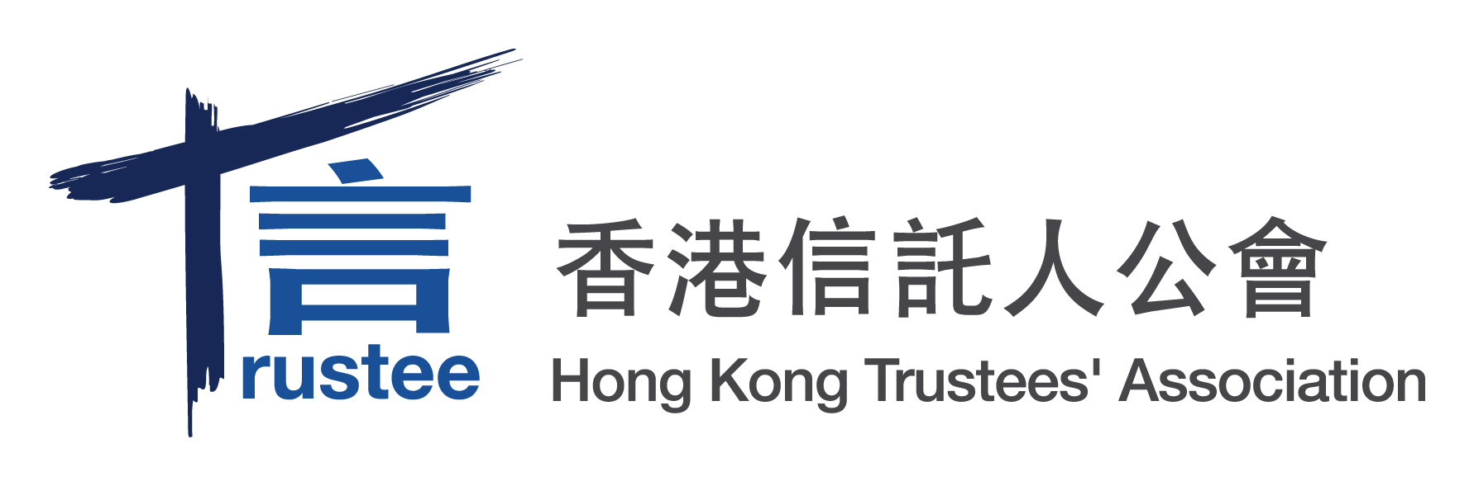
Press Statement
17 July 2013 - An Auspicious Day for HKTA
______________________________________________________________________
17 July 2013 is certainly an auspicious day for the HKTA. Today we celebrate two great events that dawn on the trust industry in Hong Kong: the passage of the Amendment Bill to the Hong Kong Trust Ordinance (HKTO) by Legislative Council and the formal launch (jointly with KPMG) the first-ever report on the HK trust industry, titled “Hong Kong Trust Industry – A Cross-Sector Perspective”.

Hong Kong is a major financial services and trust centre, but its primary trust law, the HKTO, has not been modified since 1934 while other comparable jurisdictions have embarked on modernising their trust legislation over the past decade. The trust industry saw the need to modernise our trust law and has worked closely with, and provided substantive support to, the government on this initiative. We are very happy to report that the Amendment Bill has just been passed by Legislative Council today, which will take effect on 1 December 2013.

On the occasion of the passage of the bill, Prof. KC Chan, Secretary for FSTB, said, “The Bill marks an important milestone in the development of our trust law. Through the Bill, we seek to modernise our trust law and bolster the competitiveness and attractiveness of Hong Kong's trust services industry, thereby enhancing Hong Kong's status as an international asset management centre. We are delighted to receive the support from the LegCo Bills Committee and the industry for the policy objectives of and the detailed proposals in the Bill. We believe that the proposals in the Bill would facilitate trustees in their administration of trusts, better protect the interests of beneficiaries and attract more settlors to set up trusts in Hong Kong.”

Ms Ka Shi Lau, BBS, HKTA Chairman, thanks Prof. Chan and his team for their support of the industry and looks to the government to actively promote the modernised trust law in Hong Kong and overseas.

2013年7月17日對「香港信託人公會」而言絕對是一個好日子。於今天，有兩項值得香港信託業高興的消息：《香港受託人條例》條訂草案獲立法會通過；及與「畢馬威」聯合發表了首份關於行業的報告《香港信託業 ──跨行業透視》。

香港是一主要的金融服務及信託中心，惟其基本的信託法，《香港受託人條例》，自1934年生效以來一直未經大幅修改，但在過去十年，其他相類似的司法管轄區則正在將其信託立法現代化。信託業見有為此條例進行現代化的需要，而一直就此與政府緊密地合作，並為其提供相當的支持。我們樂見此條訂草案於今天獲立法會通過，而此草案將於2013年12 月1日生效。

就草案獲通過，財經事務及庫務局局長陳家強教授說：「條例草案是我們改革信託法的一個重要里程碑。我們透過本條例草案，將信託法例現代化，並加強香港信託服務業的競爭力及吸引力，從而提升香港作為國際資產管理中心的地位。我們很高興法案委員會和業界整體上十分支持條例草案的立法目標，以及當中的具體立法建議。我們相信條例草案的建議可利便受託人管理信託，同時對受益人的利益提供適當保障，且吸引更多人來港設立信託。」

「香港信託人公會」主席劉嘉時女士，BBS，感謝陳教授及其團隊對業界的支持，並期待政府將積極地於香港及海外推廣此現代化的信託法。

Media Enquiries 傳媒查詢
Kimsten Law 羅嘉琳
Tel 直線： +852 2298 9749
Email 電郵： lau.kashi@bcthk.com

